SET 1

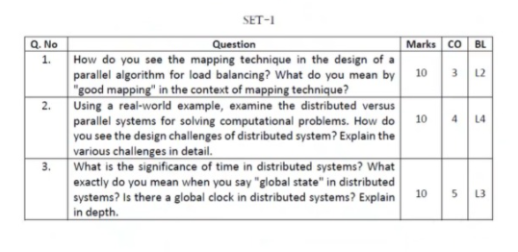

1.

Mapping Techniques for Load Balancing

n Static and Dynamic Mapping

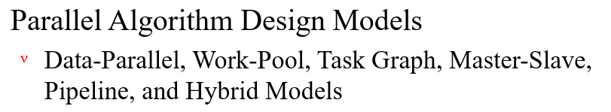

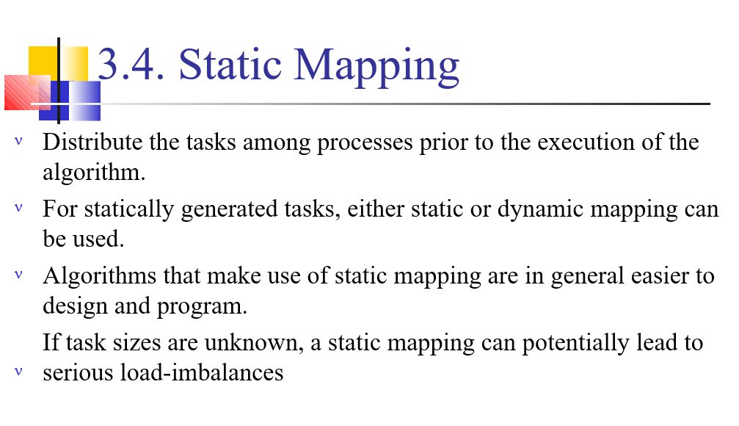

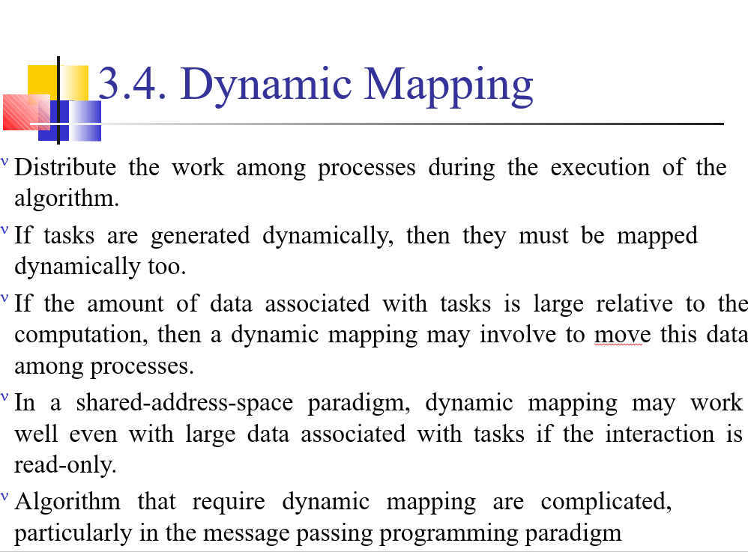

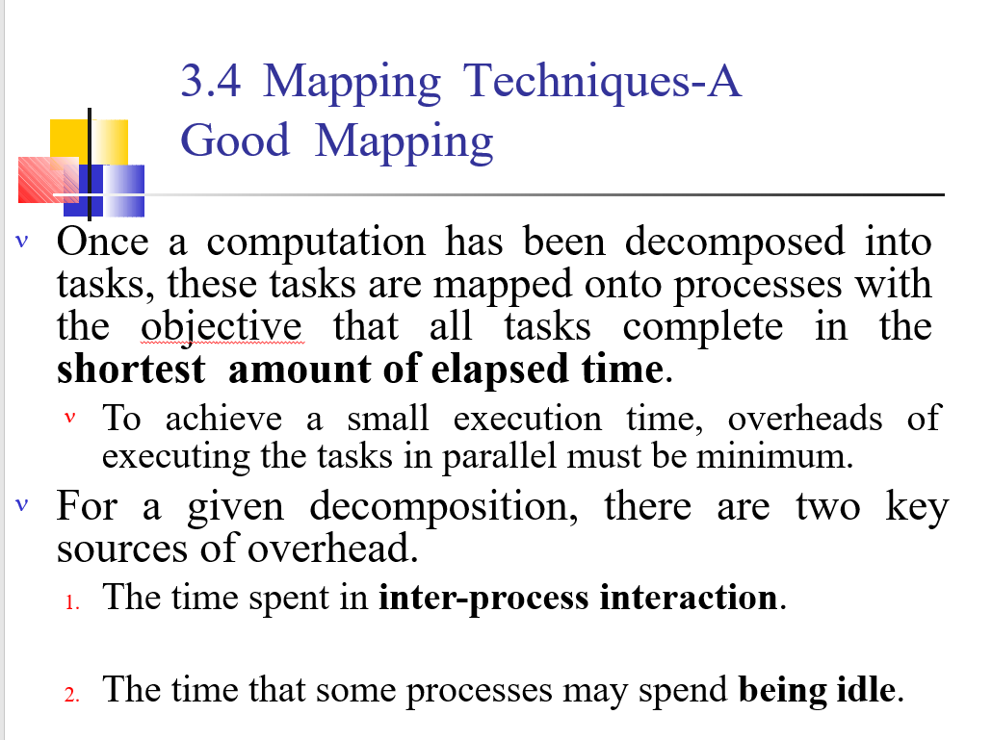

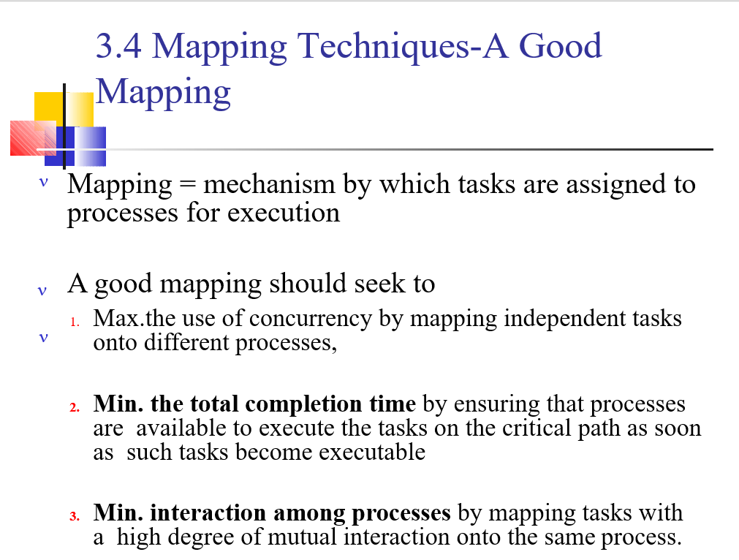

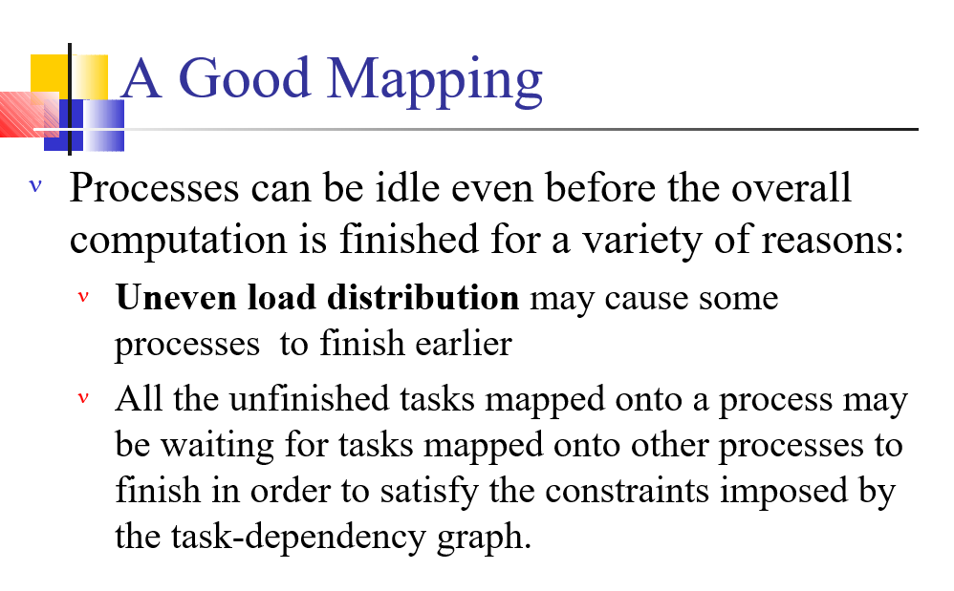

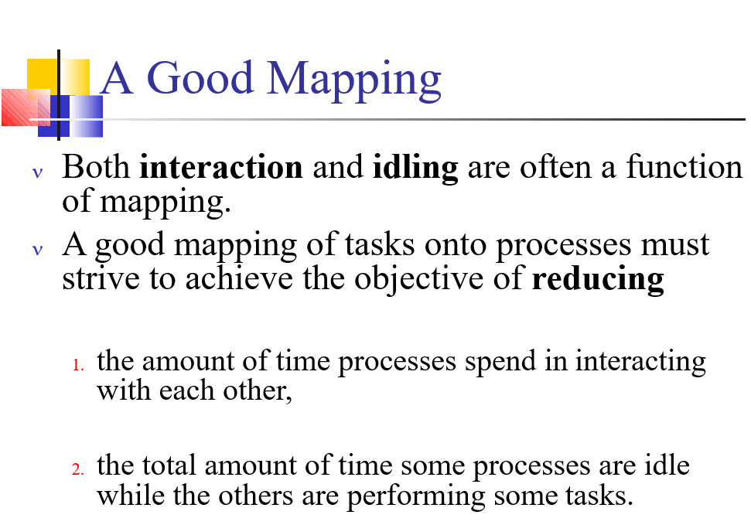

2.

The **main difference** between parallel and distributed computing is that **parallel computing allows multiple processors to execute tasks simultaneously while distributed computing divides a single task between multiple computers to achieve a common goal.**

**Examples of parallel computing**

* Smartphones. The iPhone 5 has a 1.5 GHz dual-core processor. ...
* Laptops and desktops. The Intel® processors that power most modern computers are examples of parallel computing. ...
* ILLIAC IV. ...
* NASA's space shuttle computer system. ...
* American Summit supercomputer. ...
* SETI. ...
* Bitcoin. ...
* The Internet of Things (IoT)

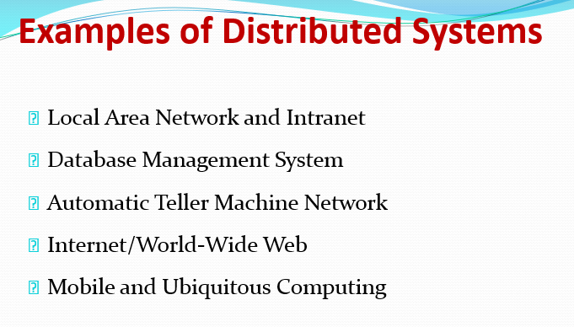

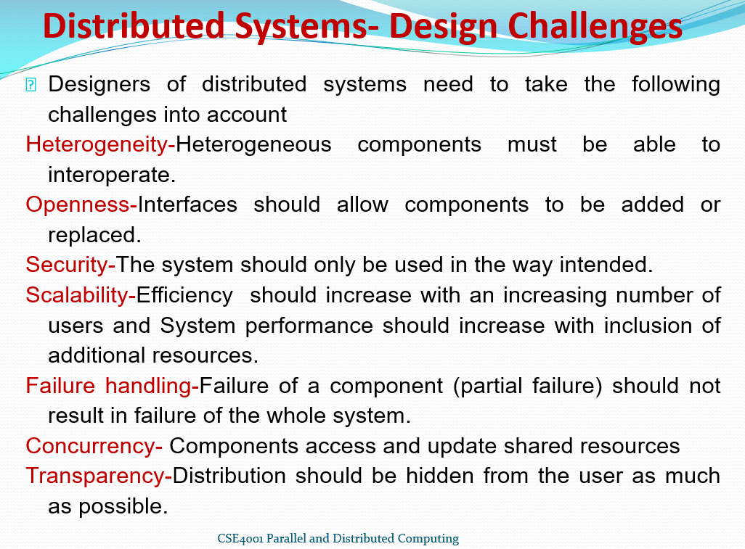

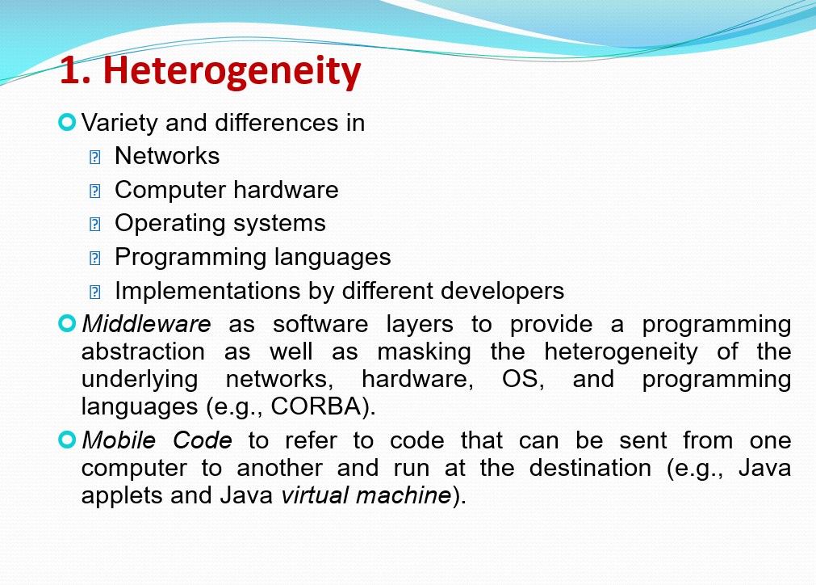

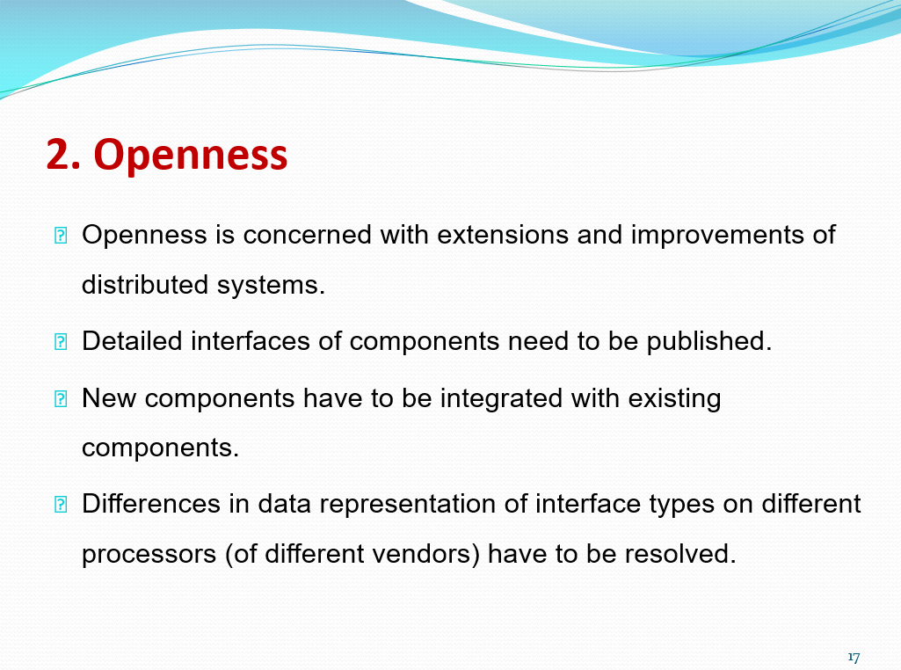

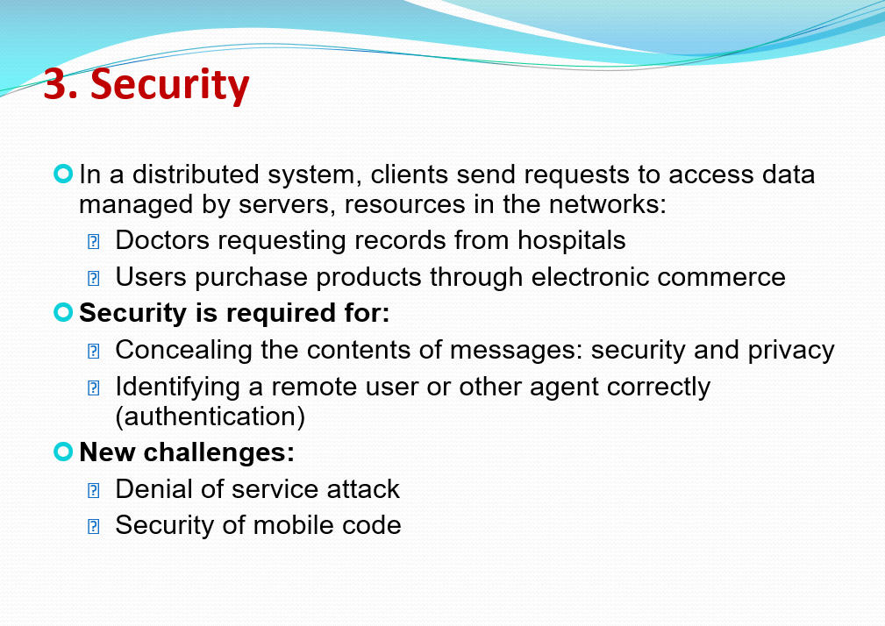

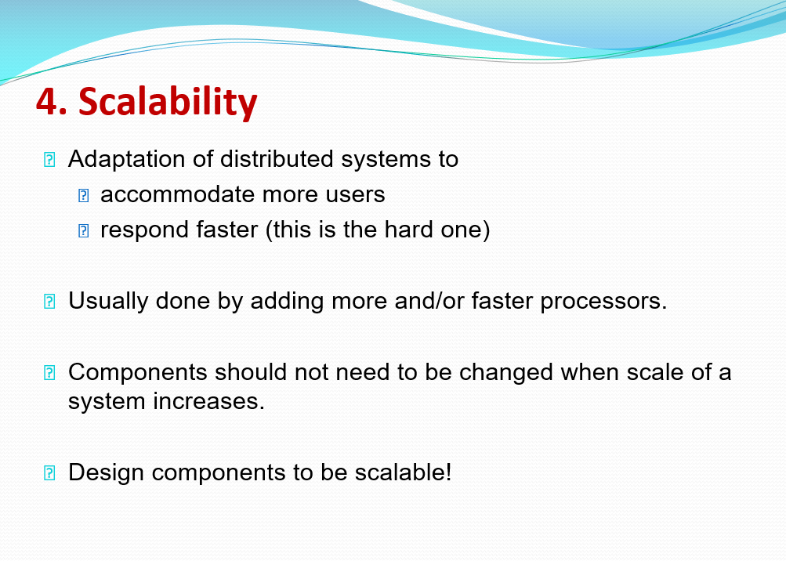

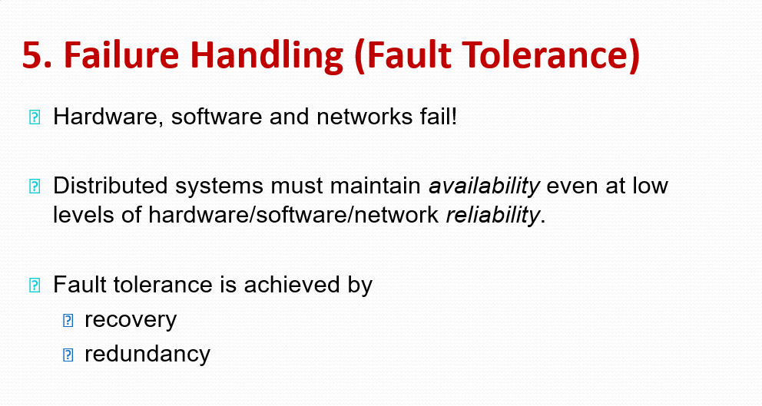

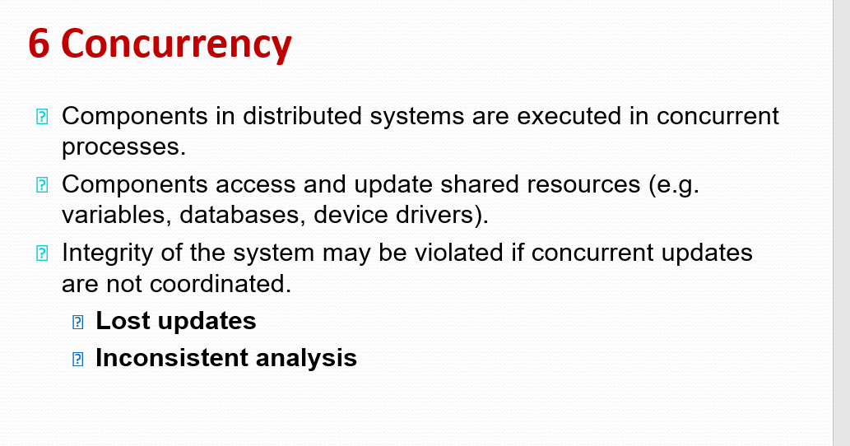

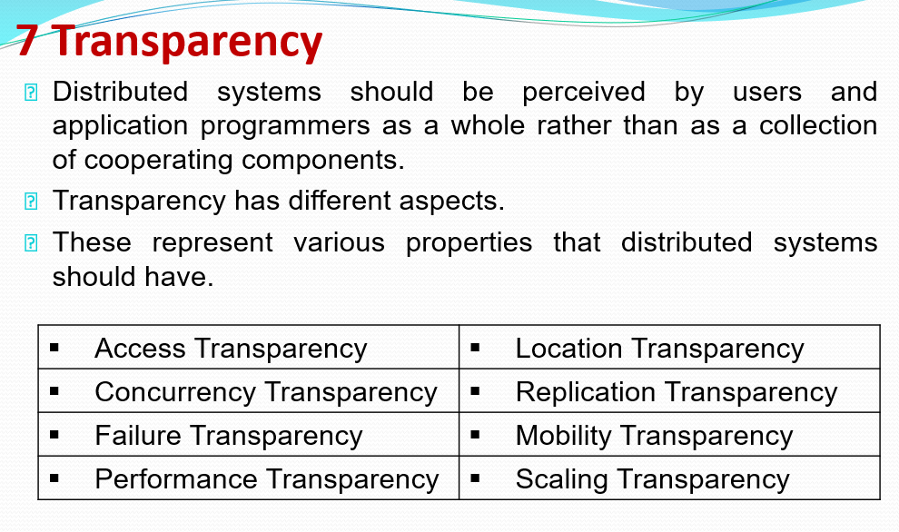

3.

Time is an important and interesting issue.

* + Time is a quantity often want to measure the happening of a certain event accurately.
    - E.g. e-commerce transaction time at merchant and bank’s computers.
  + Need time for maintaining consistency of databases.
  + Multiple computer clocks may be **skewed** and need to by synchronized – no absolute global time for all computers in a distributed systems
  + Synchronize local clock with an authoritative, external source of time.
  + Atomic oscillator clock is the most accurate physical clock. International Atomic Time and Coordinated Universal Time.

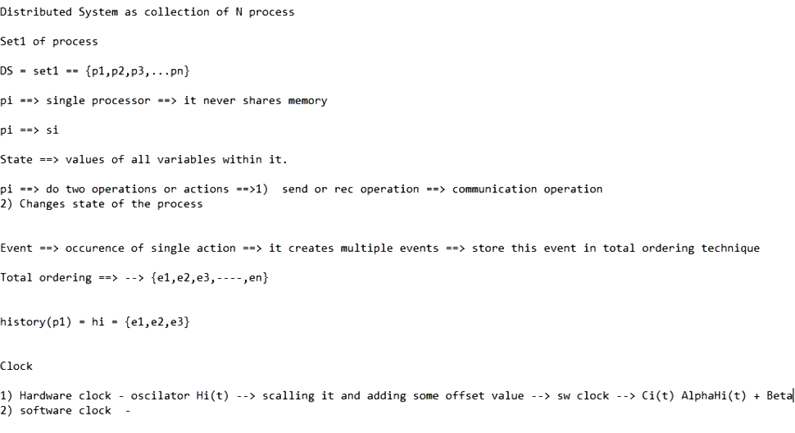

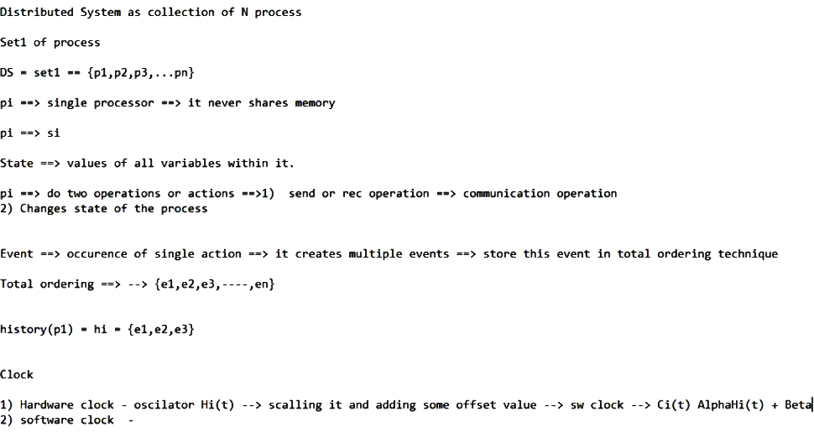

Global State:

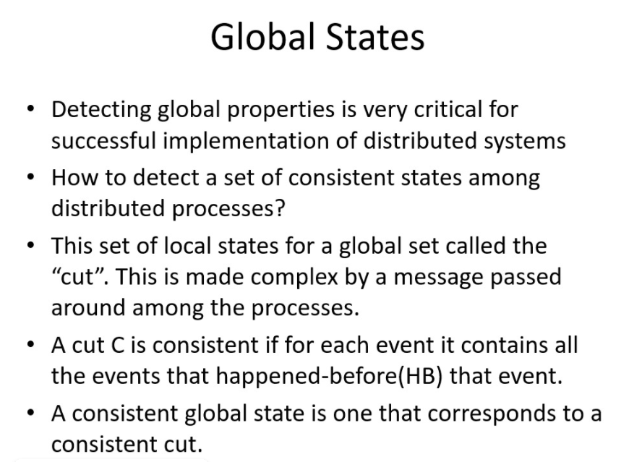

In a distributed system there is no global clock as a result different activity are possible to synchronize. ... Clock synchronization in distributed system aims at-all nodes have the same internal clock or the system is in synchronization with another external clock. Those are the drawbacks of distributed system.

SET2

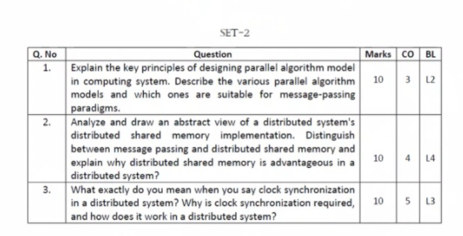

1)

(key principles of designing parallel algorithm model in computing system {not found})

**Remaing part:**

An algorithm model is a way of structuring a parallel algorithm by selecting a decomposition and mapping technique and applying the appropriate strategy to minimize interactions.

* Data Parallel Model: Tasks are statically (or semi-statically) mapped to processes and each task performs similar operations on different data.
* Task Graph Model: Starting from a task dependency graph, the interrelationships among the tasks are utilized to promote locality or to reduce interaction costs.
* Master-Slave Model: One or more processes generate work and allocate it to worker processes. This allocation may be static or dynamic.
* Pipeline / Producer-Comsumer Model: A stream of data is passed through a succession of processes, each of which perform some task on it.
* Hybrid Models: A hybrid model may be composed either of multiple models applied hierarchically or multiple models applied sequentially to different phases of a parallel algorithm.

For message-passing paradigms Master-Slave ModeL IS used

Master-Slave Model

This model is generally equally suitable to shared-address-space or message-passing paradigms, since the interaction is naturally two ways. In some cases, a task may need to be completed in phases, and the task in each phase must be completed before the task in the next phases can be generated.

2)

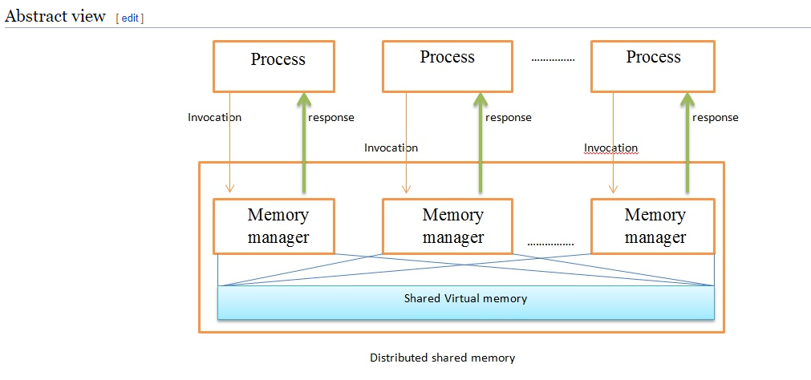

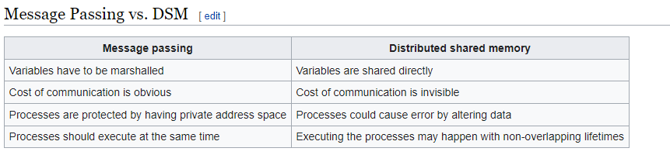

Software DSM systems also have the flexibility to organize the shared memory region in different ways. The page based approach organizes shared memory into pages of fixed size. In contrast, the object based approach organizes the shared memory region as an abstract space for storing shareable objects of variable sizes. Another commonly seen implementation uses a [tuple space](https://en.wikipedia.org/wiki/Tuple_space), in which the unit of sharing is a [tuple](https://en.wikipedia.org/wiki/Tuple).

[Shared memory architecture](https://en.wikipedia.org/wiki/Shared_memory_architecture) may involve separating memory into shared parts distributed amongst nodes and main memory; or distributing all memory between nodes. A [coherence protocol](https://en.wikipedia.org/wiki/Coherence_protocol), chosen in accordance with a [consistency model](https://en.wikipedia.org/wiki/Consistency_model), maintains [memory coherence](https://en.wikipedia.org/wiki/Memory_coherence).

Advantages[[edit](https://en.wikipedia.org/w/index.php?title=Distributed_shared_memory&action=edit&section=5)]

* Scales well with a large number of nodes
* Message passing is hidden
* Can handle complex and large databases without replication or sending the data to processes
* Generally cheaper than using a multiprocessor system
* Provides large virtual memory space
* Programs are more portable due to common programming interfaces
* Shield programmers from sending or receiving primitives

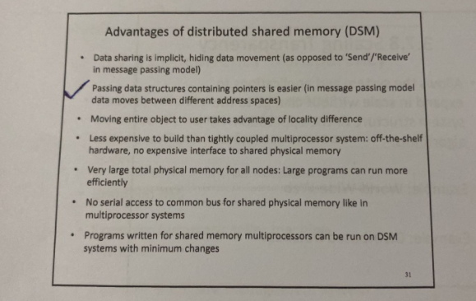

3)

What is clock synchronization in distributed system?

Clock synchronization is **a method of synchronizing clock values of any two nodes in a distributed system with the use of** external reference clock or internal clock value of the node. During the synchronization, many factors affect on a network.

Cristian's algorithm (introduced by Flaviu Cristian in 1989) is a method for clock synchronization which can be used in many fields of distributive computer science but is primarily used in low-latency intranets.

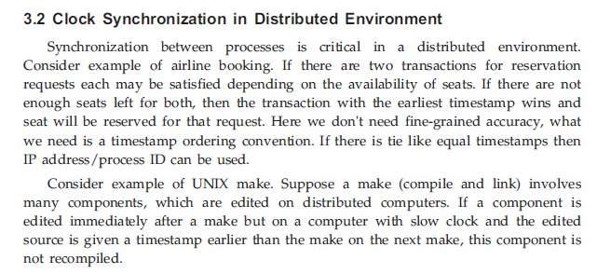

In modern computer networks, time synchronization is **critical because every aspect of managing, securing, planning, and debugging a network involves determining when events happen**. Time also provides the only frame of reference between all devices on the network.